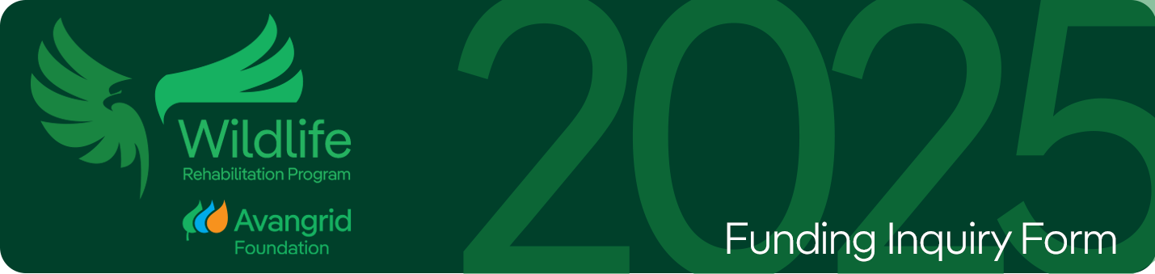

**NOTES**

* This funding inquiry form is for Avangrid Foundation Wildlife Rehabilitation. Program Grants 2025. The RFP is open from September 15, 2025, through October 15, 2025.
* Please refer to Request for Proposals Guidelines - Avangrid Foundation Wildlife Rehabilitation Program Grants 2025 for additional information.
* Form must be completed, signed and dated prior to submission.
* Form should be submitted via email to [avangridfoundation@avangrid.com](mailto:avangridfoundation@avangrid.com).
* For questions, please contact [avangridfoundation@avangrid.com](mailto:avangridfoundation@avangrid.com).
* Please note that this form does not imply an agreement to provide funds   
  or material support.

**ORGANIZATIONAL OVERVIEW**

**Organization Name:**

Enter Organization Name

**Organization Tax ID Number:**

Enter ID

**Organization Address:**

Enter address

**Organization Telephone:**

Enter telephone

**Organization Website:**

Enter URL

**Does your organization have a social media presence (Facebook, Twitter, Linked-in, ect)?**

Please list your social media accounts and handles

**Name and Title of Grant Requestor:**

Enter name and title

**Requestor contact information (Address if different than above, email, telephone):**

Enter contact information

**Name and Title of Key Executive or Key Contact:**

Enter name and title

**Key executive or Key Contact information (Address if different than above, email, telephone):**

Enter contact information

**Rehabilitation History – Length of service, number and types of wildlife handled annually, recovery and release rates:**

Enter description

**Current permits, certifications and membership related rehabilitation activities:**

Enter description

**Brief Description of Organization:**

Enter description

**Stated Mission of Organization:**

Enter mission

**Geographic Location/Service:**

Enter geographic location served

**Total Annual Organizational Operating Budget for Current Year (USD):**

Enter annual budget

**Date of Incorporation/Founding:**

Enter date

**HISTORY & RELATIONSHIP**

**Are any employees of Iberdrola, Avangrid or its subsidiaries affiliated with your organization? (Including but not limited to: Board / Committee Member, Volunteer, family member employed by organization or in receipt of services, etc.)?**

**

**If so, please name and provide summary detail of relationship:**

Enter name(s) of affiliated employee(s) and capacity in which they serve

**Has your organization requested funding from the Avangrid Foundation, AVANGRID or affiliated companies the past?**

**

**If so, in what years and for what purpose?**

Enter year/purpose of funding

**If your organization received funding from the *Avangrid Foundation* and/or *affiliated companies* please list date, purpose and amount.**

Enter historical funding information

**Please include other partners funding the project as relevant:**

Enter sources of funding

**ADDITIONAL ORGANIZATIONAL INFORMTION (ALL)**

**Diversity**

**Is your organization led by a person who identifies as a person of color?**



**Is your organization lead by a woman/femme/person identifying as a woman?**



**FUNDING REQUEST - DESCRIPTION & OBJECTIVES (ALL)**

**Title/Name of Funding Request:**

Enter a title for the request that speaks to purpose

**Project location: *Funding should be used primarily in an area of proximity to where AVANGRID has an operating presence.***

Location of project

**Funding Type: *Choose from dropdown*.**

Choose type of funding

**Requested amount:**

Enter amount (USD)

**Project Description & Goal:  *include how the request aligns with your organization’s overall stated mission and goals in the long-term. It is helpful if this area addressed the urgency or specific opportunity and the rationale for funding at this time. Include how the project will improve your organizations ability to respond to care of local wildlife resources and/or enhance educational outreach:***

Describe the project and the intended goal(s). Include alignment with overall mission.

**Objectives: *State the objectives of the funding. It is preferred that these Goals are S.M.A.R.T. (Specific-Measurable-Attainable-Relevant-Timely).***

Detail the objectives for funding.

**PROPOSED ACTIVITIES (ALL)**

**Activities: *Detail the activities / key milestones that will be undertaken to support the stated objectives. Please be as specific as possible and use bullets over narrative where possible.***

Describe activities and key milestones

**EXPECTED OUTCOMES & IMPACT (ALL)**

**Project Outcomes & Impact: *State specifically what will be accomplished with the specific funds if awarded that speaks directly to expected immediate results and longer-term impact. If expected economic impact is evaluated, please include.***

Describe expected outcomes, accomplishments and impact

***If there is a multiplier effect (e.g. public-private partnerships, impact on policy, jobs created), please include.***

Describe expected outcomes, accomplishments and impact

**Beneficiaries: *Describe the target groups/community and/or wildlife that is intended to benefit and number of beneficiaries over a specific period of time.***

Describe target beneficiaries including any protected classes of individuals.

**#Direct/timeframe:** # of direct beneficiaries and specific time period

**#Indirect/timeframe:** # of indirect beneficiaries and specific time period

**What tools or methods will be used to measure and evaluate impact?**

Describe tools

**How do you determine success of the program/investment/event? How will the organization confirm that the stated objectives have been achieved?**

Factors for determining success

**\*\*CAPITAL CAMPAIGN REQUESTS ONLY\*\***

**Why did the organization decide to have a Capital Campaign at this time?**

Enter rationale

**What is the fundraising goal (amount) and what percent has been raised to date?**

Enter goal and amount raised

**How will organization adapt to growth through capital campaign (funding, staffing, programmatic goals, etc.)?**

Describe expected adaptation

**EXPECTED PRODUCTS (ALL)**

**Detail any tangible results, if applicable, specific to Foundation support (e.g. construction/restoration, printed report, internet publication, display, exhibit, conference, photos/video/media, etc.)**

Describe product results

**How will your organization recognize the contribution from Avangrid Foundation in a way that is valuable to your organization? *Please include specific suggestions related to, but not limited to marketing/branding/naming rights, logo use, social media postings/“live event”, press release or other written communication, video production, media events, recognition at an event/fundraiser, etc. Timing and specific actions are preferred. If additionalresources are needed to achieve this, please specify. (This is an area where we support creativity!)***

Detail communications plan

**OTHER INFORMATION (ALL)**

**Please submit any additional information that will support your application.**

Enter any additional information here

**PLEASE INCLUDE THE FOLLOWING DOCUMENTS WITH YOUR SUBMISSION:**

* W9 (two years old or less)
* Most recent 990 (attachment)
* IRS determination letter
* Summary Budget & Brief Narrative (organizational or program depending on type of request)
* Please return the completed document in **two formats**:
  + **Scanned Copy**: If you choose to print and sign the document, please scan and email it back as a PDF or image file.
  + **Electronic Version**: In addition to the scanned copy, please also send back the **editable Word document** with your information filled in electronically. This ensures we have both a signed version and a digital version for processing.
* Board of Directors (attachment)
* Annual report (as available)
* Certificates, Permits, Licensing
* Any other supporting documents including media, pictures or supplemental information.
* Include this completed word document

**e-SIGNATURE (ALL)**

**Preferably insert image of signature here by choosing box below and pressing “Enter.”**

­­­­­­­­­­­­­­­­­­­­­­ Enter Title & Date ___________________________________________________________________

Name: Title: Date:

­­­­­­­­­­­­­­­­­­­­­­­­