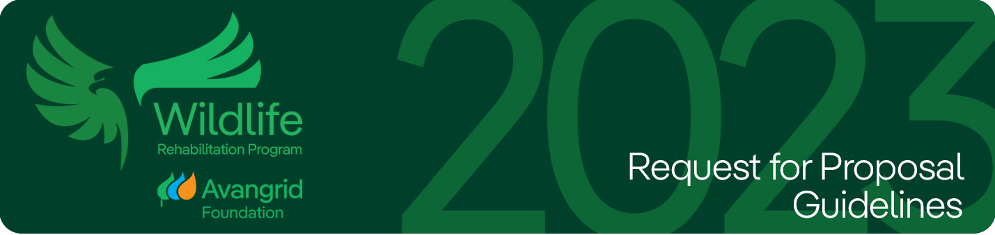
Avangrid Foundation Wildlife Rehabilitation Program RFP
Request for Proposals: Avangrid Foundation Wildlife Rehabilitation Grants 2023
Applications Accepted: September 5, 2023 – September 25, 2023
The Avangrid Foundation has provided us with this grant at a critical time for wildlife rehabs across the country as we all deal with Highly Pathogenic Avian Influenza (HPAI). The HPAI virus has made it critical for us to be able to quarantine all new avian patients upon admission to avoid spreading this virus throughout our facility. This virus would be deadly to any raptor patients, as well as our entire team of educational avian animal ambassadors. By providing these funds, the Avangrid Foundation will make it possible for us to break ground in Spring 2023 to erect a building specifically dedicated as a quarantine facility on our grounds. This will allow us to safely admit and triage multiple new patients at the same time while keeping them safely separated during the quarantine period. Our most heartfelt thank you to the Avangrid Foundation for helping us continue to care for the sick, injured, and orphaned wildlife of Southern Oregon.
Laura Hale, President Eileen Fielding, Director, Sharon Audubon Center
Avangrid Foundation is independent, pro-bono, mission-driven, 501(c)(3) organization that serves as the primary philanthropic arm of AVANGRID in the United States, with a focus on building sustainable communities and helping at-risk “persons” (and wildlife!)
In collaboration with our family of companies, including our Wildlife Protection Program (WPP) team, the Foundation provides opportunities for wildlife rehabilitators to apply for grants to support their operational capabilities and expand outreach to communities historically in and around our utility service areas and wind and solar facilities. Numerous rehabilitation centers nationwide, which treat a variety of injured wildlife - from mammals to reptiles to birds - have received funding from the Avangrid Foundation to help improve care and services since 2016.
The goals of the grants include:
- Support community/regional wildlife rehabilitation centers caring for injured wildlife.
- Support outreach to the public to improve knowledge and awareness of wildlife resources and renewable energy; through providing information, training, and resources.
- Foster a relationship with rehabilitation centers to enhance mutual awareness, aid their understanding of the value of energy/renewable energy, and strengthen relationships with the environmental community where we have an operating presence.

This year we are committed to expand funding opportunities and geography to reach rehabilitators everywhere AVANGRID does business, including organizations focused on coastal and marine life.
Many of the partnerships established through this program have spanned multiple years, deepening our collaboration and collective ability to make real positive impact for the good of the animals and our environment.
Please find a link to the press release from our 2022 grantees. A summary of the grants can be found here.
Eligibility Requirements & Information:
- Eligible 501(c)(3) organizations or qualified entities may apply.
- Organizations whose primary mission includes wildlife rehabilitation.
- Organizations with more than one year of operating activity.
- Organizations that hold current, applicable permits from the appropriate agencies to handle and rehabilitate wildlife.
- All organizations must complete and e-mail a funding request by midnight on September 25th to avangridfoundation@avangrid.com.
For additional information on Avangrid Foundation funding guidelines please visit this link.
Please note that preference may be given to:
- Organizations operating in proximity to where AVANGRID has an operating presence. To learn more, visit this link .
- Organizations that rehabilitate avifauna, including raptors, other large birds & shorebirds
- Organizations that rehabilitate/protect bats
- Organizations that rehabilitate threatened and endangered wildlife (all)
- Organizations that rehabilitate marine life
Successful award notification will be made by December 31, 2023, via email.
For Information contact: avangridfoundation@avangrid.com
*Submitting an application does not constitute a contract or an agreement to fund by the Avangrid Foundation*

* AVANGRID, Inc. is an affiliate of Iberdrola, S.A. The AVANGRID operating companies include Avangrid Renewables, Berkshire Gas, Central Maine Power, Connecticut Natural Gas, Maine Natural Gas, New York Gas & Electric, Rochester Gas and Electric, Southern Connecticut Gas and United Illuminating.

